# Modelling the impact of the proposed rent decrease on affordable and social rent

The conservative government has proposed a fall in affordable and social rents of 1% per annum from 2016 for four years. You can use Pamwin Plus to model the impact - not just on the current programme, but on every completed scheme in the database. However, we assume that completed schemes will be assessed as part of the wider business plan, and you’ll need to use Pamwin Plus to:

* Model the impact on your current programme and report to board
  + By changing inflation records for affordable and social rent, including the Target Rent inflation tables
* Amend your current financial assumptions and/or existing schemes accordingly

The following schemes will be directly affected by a change to inflation records:

1. Any affordable or social scheme still being appraised
2. Any affordable or social scheme on site

These schemes will be indirectly affected

1. Any completed social scheme, if the Target Rent calculation has been left switched on
2. Any market rent or shared ownership scheme using the same inflation table (**this can be sorted out**)

The safest way to model the impact of such a dramatic change is to copy your live database into a test or training environment, make the changes in test/training and compare the results to the live system before deciding what to do. If this is not possible, you can pot-sample your live data.

This document sets out options for modelling either in a training/test environment, or in a live environment, before outlining how to commit changes in the live environment. Here is a process diagram setting out the modelling options:



## Modelling the impact in a training / test environment

The outline steps are as follows:

1. Update your test/training environment with live data (ask IT)
2. Amend the inflation tables under Data Maintenance > Data Defaults
3. Amend the HCA target rent tables, and the target rent caps, and check the extrapolation factors
4. Compare the results between test and live

### Amending inflation tables

* Got to data Maintenance>Data Defaults>Inflation Rates (alternative)
* Sort by the **Source** column to view your current live inflation records used by affordable and social schemes
* The crucial years are 2014, 2015 and 2019. The records should end up looking like this:

|  |  |  |  |  |  |  |  |  |  |  |  |
| --- | --- | --- | --- | --- | --- | --- | --- | --- | --- | --- | --- |
| **Funding Year Commencing** | **Source** | **RPI** | **Management** | **Maintenance** | **Reconstruction** | **Other Income** | **Service Charges** | **Service Costs** | **Service Staffing** | **House Prices** | **RSL Rent** |
| **2014** | *Your inflation series* | Your Assumption | | | | | | | | | |
| **2015** | *Your inflation series* | Your Assumption | | | | | | | | | -1 |
| **2019** | *Your inflation series* | Your Assumption | | | | | | | | | |

* If you have not got records for 2014, 2015 and 2019 you’ll need to set them up as follows:
  + Click on “Add New Record”
  + Enter 2014 or 2015 or 2019 in the Funding Year Commencing
  + In Source, select *Your inflation series*

### Amending HCA Target rent inflation

Target rent inflation tables are held under Data Maintenance > Other HCA Tables > Rent Determination

The table should be amended to look like this:

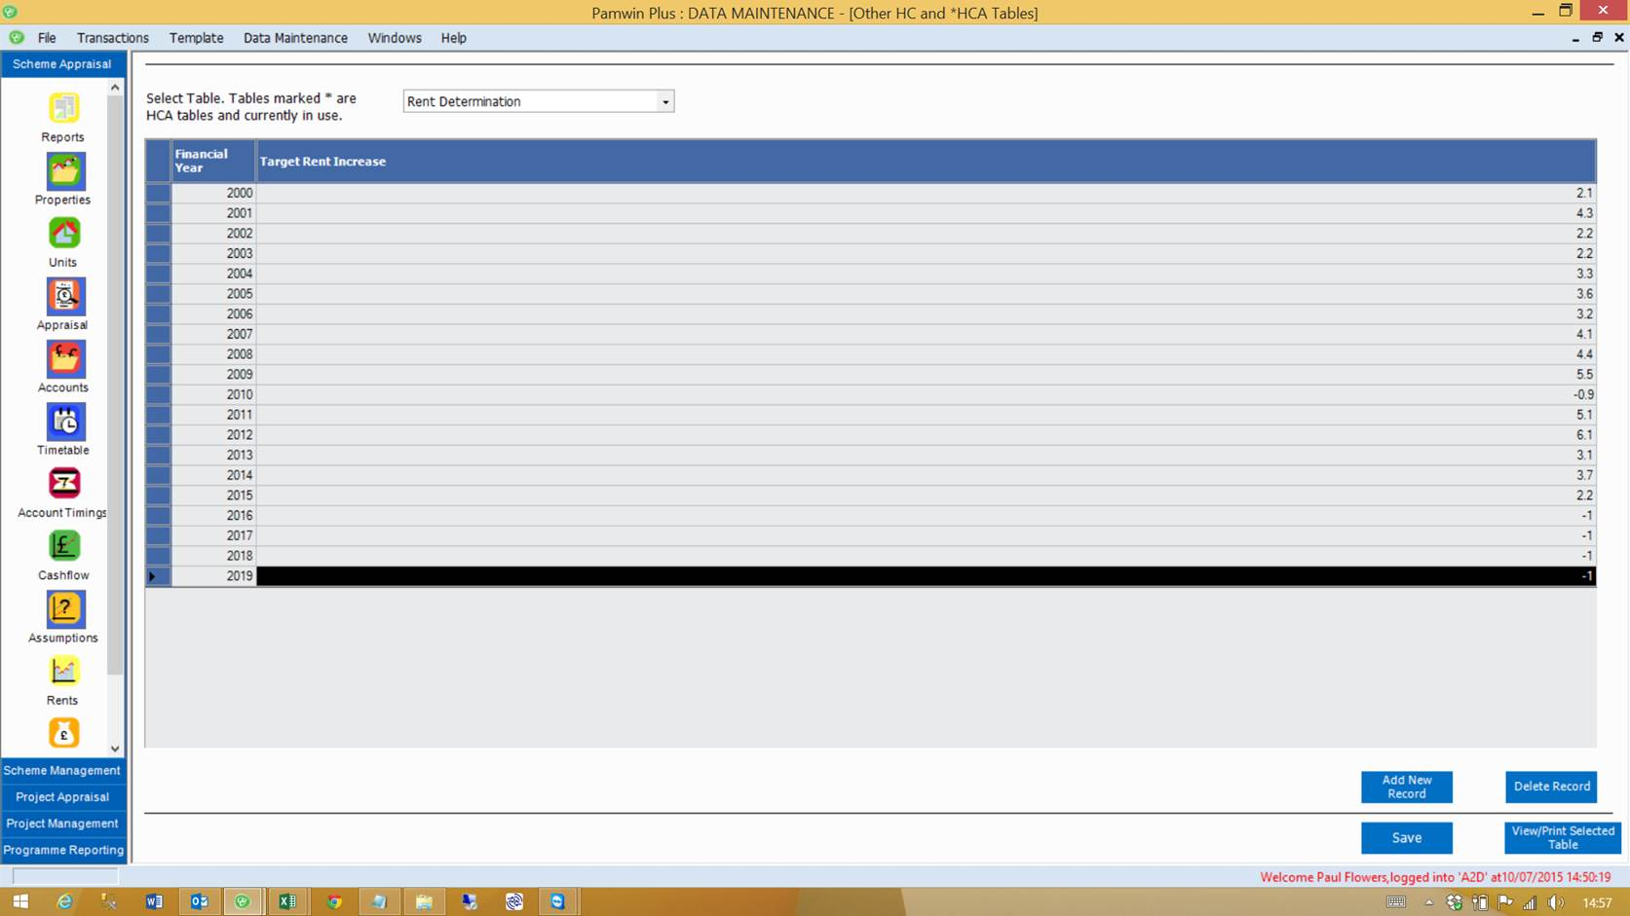

To add rows, click ‘add new record’, type in the year and target rent increase, then hit Save.

### Checking Target Rent Extrapolation

Pamwin needs to know what target rent inflation to use after the last record found in the rent determination table – what should target rent be extrapolated by?. This field is found under Data Maintenance > Parameters > Rent, Service and LCHO Parameters

If you assume CPI is going to be 2%, then Target rent should be extrapolated by 3%, and Target cap by 3.5%

### Amending Target Rent caps

Go to Data Maintenance > Other HCA Tables > Bedroom weightings. The table should be set up to look like the one below from 2013 onwards, but if you have access to your database you can contact M3 for a script that carries out a bulk update. Otherwise, click ‘Add new record’, and type in each of these lines, saving between each one:

|  |  |  |  |  |
| --- | --- | --- | --- | --- |
| 2013 | 1 | TRUE | 80 | 132.16 |
| 2013 | 1 | FALSE | 90 | 132.16 |
| 2013 | 2 | FALSE | 100 | 139.92 |
| 2013 | 3 | FALSE | 110 | 147.7 |
| 2013 | 4 | FALSE | 120 | 155.47 |
| 2013 | 5 | FALSE | 130 | 163.24 |
| 2013 | 6 | FALSE | 140 | 171.01 |
| 2014 | 1 | TRUE | 80 | 137.71 |
| 2014 | 1 | FALSE | 90 | 137.71 |
| 2014 | 2 | FALSE | 100 | 145.8 |
| 2014 | 3 | FALSE | 110 | 153.9 |
| 2014 | 4 | FALSE | 120 | 162 |
| 2014 | 5 | FALSE | 130 | 170.1 |
| 2014 | 6 | FALSE | 140 | 178.19 |
| 2015 | 1 | TRUE | 80 | 141.43 |
| 2015 | 1 | FALSE | 90 | 141.43 |
| 2015 | 2 | FALSE | 100 | 149.74 |
| 2015 | 3 | FALSE | 110 | 158.06 |
| 2015 | 4 | FALSE | 120 | 166.37 |
| 2015 | 5 | FALSE | 130 | 174.69 |
| 2015 | 6 | FALSE | 140 | 183 |
| 2016 | 1 | TRUE | 80 | 140.72 |
| 2016 | 1 | FALSE | 90 | 140.72 |
| 2016 | 2 | FALSE | 100 | 148.99 |
| 2016 | 3 | FALSE | 110 | 157.27 |
| 2016 | 4 | FALSE | 120 | 165.54 |
| 2016 | 5 | FALSE | 130 | 173.82 |
| 2016 | 6 | FALSE | 140 | 182.09 |
| 2017 | 1 | TRUE | 80 | 140.02 |
| 2017 | 1 | FALSE | 90 | 140.02 |
| 2017 | 2 | FALSE | 100 | 148.25 |
| 2017 | 3 | FALSE | 110 | 156.48 |
| 2017 | 4 | FALSE | 120 | 164.71 |
| 2017 | 5 | FALSE | 130 | 172.95 |
| 2017 | 6 | FALSE | 140 | 181.18 |
| 2018 | 1 | TRUE | 80 | 139.32 |
| 2018 | 1 | FALSE | 90 | 139.32 |
| 2018 | 2 | FALSE | 100 | 147.51 |
| 2018 | 3 | FALSE | 110 | 155.7 |
| 2018 | 4 | FALSE | 120 | 163.89 |
| 2018 | 5 | FALSE | 130 | 172.09 |
| 2018 | 6 | FALSE | 140 | 180.27 |
| 2019 | 1 | TRUE | 80 | 138.62 |
| 2019 | 1 | FALSE | 90 | 138.62 |
| 2019 | 2 | FALSE | 100 | 146.77 |
| 2019 | 3 | FALSE | 110 | 154.92 |
| 2019 | 4 | FALSE | 120 | 163.07 |
| 2019 | 5 | FALSE | 130 | 171.23 |
| 2019 | 6 | FALSE | 140 | 179.37 |
| 2020 | 1 | TRUE | 80 | 142.78 |
| 2020 | 1 | FALSE | 90 | 142.78 |
| 2020 | 2 | FALSE | 100 | 151.17 |
| 2020 | 3 | FALSE | 110 | 159.57 |
| 2020 | 4 | FALSE | 120 | 167.96 |
| 2020 | 5 | FALSE | 130 | 176.37 |
| 2020 | 6 | FALSE | 140 | 184.75 |

### Comparing the results between test and live

* In each instance of Pamwin, open a selection that contains all your programmed affordable and social rent schemes
* On the Scheme Selector screen, click on Calculate KPIs to fill in the missing values. This may take some time on the test environment, as all KPIs will have been reset by the changes to inflation.
* Run out your standard programme report, and compare the two data sets

## Modelling the impact in a live Pamwin environment

The outline steps are as follows:

1. Create a new inflation series showing the rent fall
2. Update the HCA target rent tables, including caps (but be prepared to set them back again)
3. Use “save as version” on a scheme-by-scheme basis, and substitute the new ‘rent fall’ inflation series for the existing one
4. Reverse the HCA target rent table changes (unless you wish to go live with them)

### Create a new inflation series

Got to data Maintenance>Data Defaults>Inflation Rates (alternative)

Create three new rows as follows

* Click on “Add New Record”
* Enter 2014 in the Funding Year Commencing
* In Source, select “Add New” and call your new series ‘Rent fall’ or similar
* Use your own assumptions for all inflation rates except for the 2015 RSL rent rate, as follows:

|  |  |  |  |  |  |  |  |  |  |  |  |
| --- | --- | --- | --- | --- | --- | --- | --- | --- | --- | --- | --- |
| **Funding Year Commencing** | **Source** | **RPI** | **Management** | **Maintenance** | **Reconstruction** | **Other Income** | **Service Charges** | **Service Costs** | **Service Staffing** | **House Prices** | **RSL Rent** |
| **2014** | Rent Drop 1% (AR) | Your Assumption | | | | | | | | | |
| **2015** | Rent Drop 1% (AR) | Your Assumption | | | | | | | | | -1 |
| **2019** | Rent Drop 1% (AR) | Your Assumption | | | | | | | | | |

Finally, log out and log back in again.

### Amending the HCA target rent tables

See previous pages on updating target rent inflation, caps and extrapolation rates

### Using ‘Save as’ to check new inflation

* Open any scheme to be tested, and click on ‘File > Save as version’
* In the new version, go to the Assumptions screen and change the inflation used to ‘rent fall’ (or whatever you called it)
* Calculate the KPIs and compare this version to the previous version

### Undoing all the HCA target rent changes

If you have asked us for a script to carry out bulk updating we will also issue one that reverses the changes. Otherwise go through line-by-line and delete all the rows added.

## Applying the changes to the live environment

The instructions for applying changes to the live environment are the same as for making changes to the test/training system – as outlined above. However, many of you use one inflation series for all tenures, and Pamwin only has one column for Rent inflation in the inflation tables. The exercises above were just looking at the impact on social or affordable schemes, either *en masse* in the test/training environment, or as a pot-sample in the live environment.

If the inflation changes are applied, they should not be allowed to affect market rent or shared ownership rents.

There are two options:

* Use the ‘different inflation after completion’ feature on the Assumptions screen
* Create different inflation series to be used by different tenures

The ‘different inflation after completion’ feature is straightforward – it replaces the rent inflation used in the KPI calculation with a figure entered on the Assumptions screen as RPI/CPI + X. This will work well if you are not assuming any rent inflation from appraisal to completion.

If you are assuming market rents rise between appraisal and completion, then you’ll need to look at creating a new inflation series.

We now know we have to allow different rent columns within one inflation table – this will happen over the summer. In the meantime, we can provide you with a script to carry out a bulk update of inflation assumptions.

As always, do call us with any questions, and here is a process chart of your options:

